Analysis of Building Frames (Using Kani’s Method)
Gasper Kani, a German engineer, developed another distribution procedure based on slope deflection equations. This method is very useful for the analysis of multistorey frames. The greatest advantage of this method is, even if a mistake is committed in distribution in one of the cycles, it converges finally to the correct answer. Even today, many practising engineers who are not familiar with computer methods, use Kani's method for the analysis of 3 to 4 storey building frames.
This method is first explained for structures with fixed ends. Then, the modifications to handle simply supported and overhanging ends are discussed. Analysis of symmetric frames making use of the symmetry is also explained, after which an analysis of general frames is taken up.
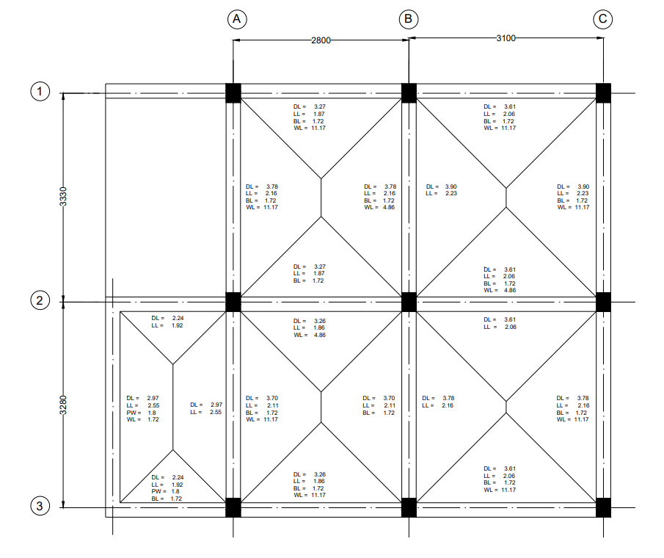
Figure 1: Beam Layout
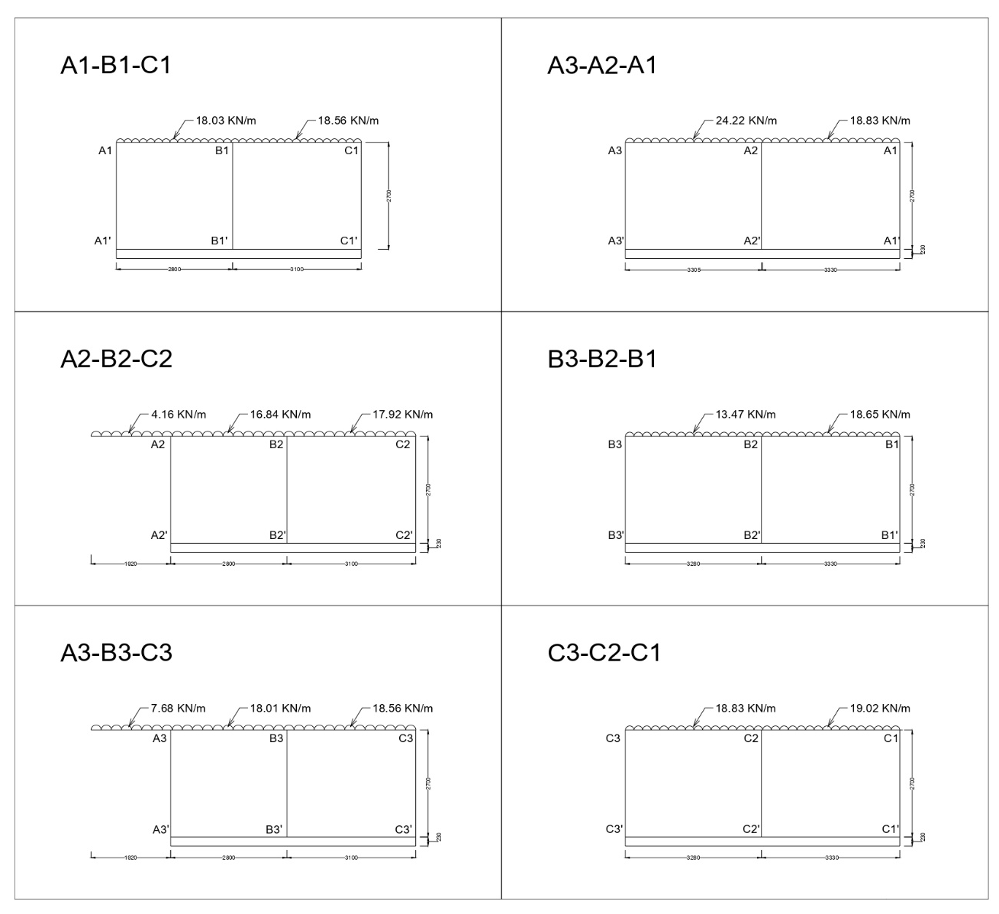
Figure 2: Frames.

Analysis of Frame A2-B2-C2
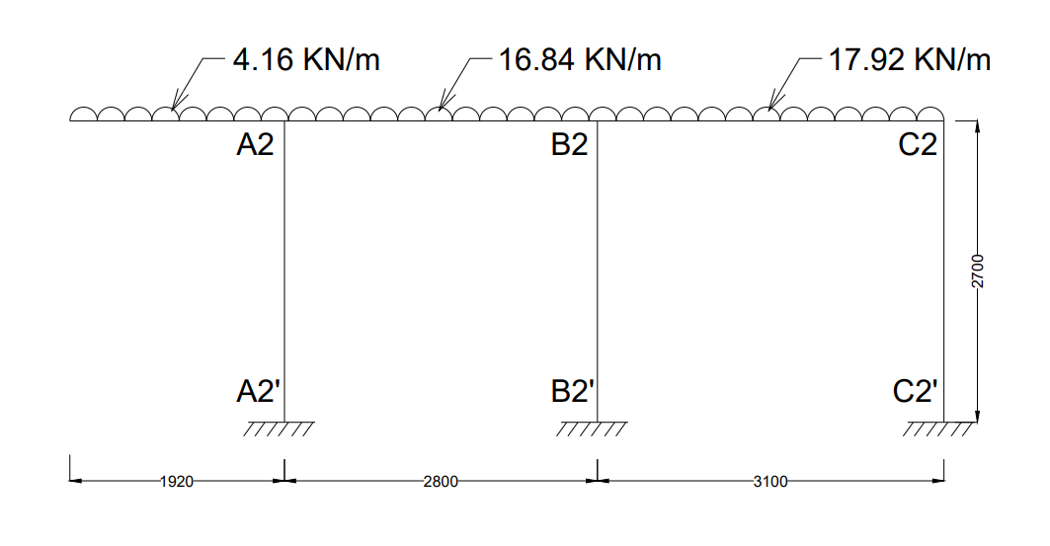
Step 1: Fixed End Moments
MF_{Overhanging} = $\frac{{WL}^{2}}{2}$ = $\frac{{4.16 ×1.92}^{2}}{2}$ = 7.67 KN-m
MF_{A2B2} = $\frac{-{WL}^{2}}{12}$ = $\frac{-16.84 × {2.8}^{2}}{12}$ = -11.00 KN-m
MF_{B2A2} = $\frac{{WL}^{2}}{12}$ = $\frac{-16.84 × {2.8}^{2}}{12}$ = +11.00 KN-m
MF_{B2C2} = $\frac{-{WL}^{2}}{12}$ = $\frac{-17.92 × {3.1}^{2}}{12}$ = -14.35 KN-m
MF_{C2B2} = $\frac{{WL}^{2}}{12}$ = $\frac{17.92 × {3.1}^{2}}{12}$ = +14.35 KN-m
Fixed end moments in All the columns are zero.
i.e,
MF_{A2A2՛ =} MF_{A2՛A2} = MF_{B2B2՛ =} MF_{B2՛B2 =} MF_{C2C2՛ =} MF_{C2՛C2} = 0

Step 2: Rotation Factor $\left(R.F = -\frac{1}{2} \left(\frac{k}{Σk}\right) \right)$, $\left(k= \frac{4EI}{L}\right)$
Joints | Members | Stiffness ($k$) | $$Σk$$ | R.F
A2 | A2B2 | 1.428EI | 2.909EI | -0.245
A2 | A2A2՛ | 1.481EI | 2.909EI | -0.255
B2 | B2A2 | 1.428EI | 4.200EI | -0.170
B2 | B2C2 | 1.290EI | 4.200EI | -0.154
B2 | B2B2՛ | 1.481EI | 4.200EI | -0.176
C2 | C2B2 | 1.290EI | 2.771EI | -0.233
C2 | C2C2՛ | 1.481EI | 2.771EI | -0.267

Stiffness ($k$) $\left(k=\left(\frac{4EI}{L}\right)\right)$
K_{A2B2} = $\left(\frac{4EI}{2.8}\right)$ = 1.428EI
K_{A2A2՛} = $\left(\frac{4EI}{2.7}\right)$ = 1.481EI
K_{B2A2} = $\left(\frac{4EI}{2.8}\right)$ = 1.428EI
K_{B2C2} = $\left(\frac{4EI}{3.1}\right)$ = 1.290EI
K_{B2B2՛} = $\left(\frac{4EI}{2.7}\right)$ = 1.481EI
K_{C2B2} = $\left(\frac{4EI}{3.1}\right)$ = 1.290EI
K_{C2C2՛} = $\left(\frac{4EI}{2.7}\right)$ = 1.481EI
Sum of Stiffness ∑$k$ at Joints
A2: 1.428EI + 1.481EI = 2.909EI
B2: 1.428EI + 1.290EI + 1.481EI = 4.200EI
C2: 1.290EI + 1.481EI = 2.771EI
Rotation Factor $\left(R.F = -\frac{1}{2} \left(\frac{k}{Σk}\right) \right)$
R.F_{A2B2} = $-\frac{1}{2} \left(\frac{1.428EI}{2.909EI}\right)$ = -0.245
R.F_{A2A2՛} = $-\frac{1}{2} \left(\frac{1.481EI}{2.909EI}\right)$= -0.255
R.F_{B2A2} = $-\frac{1}{2} \left(\frac{1.428EI}{4.200EI}\right)$ = -0.170
R.F_{B2C2} = $-\frac{1}{2} \left(\frac{1.290EI}{4.200EI}\right)$ = -0.154
R.F_{B2B2՛} = $-\frac{1}{2} \left(\frac{1.481EI}{4.200EI}\right)$ = -0.176
R.F_{C2B2} = $-\frac{1}{2} \left(\frac{1.290EI}{2.771EI}\right)$ = -0.233
R.F_{C2C2՛} = $-\frac{1}{2} \left(\frac{1.481EI}{2.771EI}\right)$ = -0.267

Step 3: Displacement Factor $\left(D.F = -\frac{3}{2} \left(\frac{k}{Σk}\right) \right)$
Storey | Members | $$k$$ | $$Σk$$ | D.F
1 | A2A2՛ | 1.481EI | 4.444EI | -0.5
1 | B2B2՛ | 1.481EI | 4.444EI | -0.5
1 | C2C2՛ | 1.481EI | 4.444EI | -0.5

Stiffness ($k$) $\left(k=\left(\frac{4EI}{L}\right)\right)$
K_{A2A2՛} = $\left(\frac{4EI}{2.7}\right)$ = 1.481EI
K_{B2B2՛} = $\left(\frac{4EI}{2.7}\right)$ = 1.481EI
K_{C2C2՛} = $\left(\frac{4EI}{2.7}\right)$ = 1.481EI
Sum of Stiffness ∑$k$ at Storey
∑$k$ = 1.481EI + 1.481EI + 1.481EI = 4.444EI
Displacement Factor $\left(D.F = -\frac{3}{2} \left(\frac{k}{Σk}\right) \right)$
D.F_{A2A2՛} = $-\frac{3}{2} \left(\frac{1.481EI}{4.444EI}\right)$= -0.5
D.F_{B2B2՛} = $-\frac{3}{2} \left(\frac{1.481EI}{4.444EI}\right)$ = -0.5
D.F_{C2C2՛} = $-\frac{3}{2} \left(\frac{1.481EI}{4.444EI}\right)$ = -0.5

Rotation and Displacement Contribution
starting FEM at Joint A2 ∑FEM will be the sum of the overhang and the beam:
∑FEM_{A2} = 7.67 + (-11.00) = -3.33KN-m
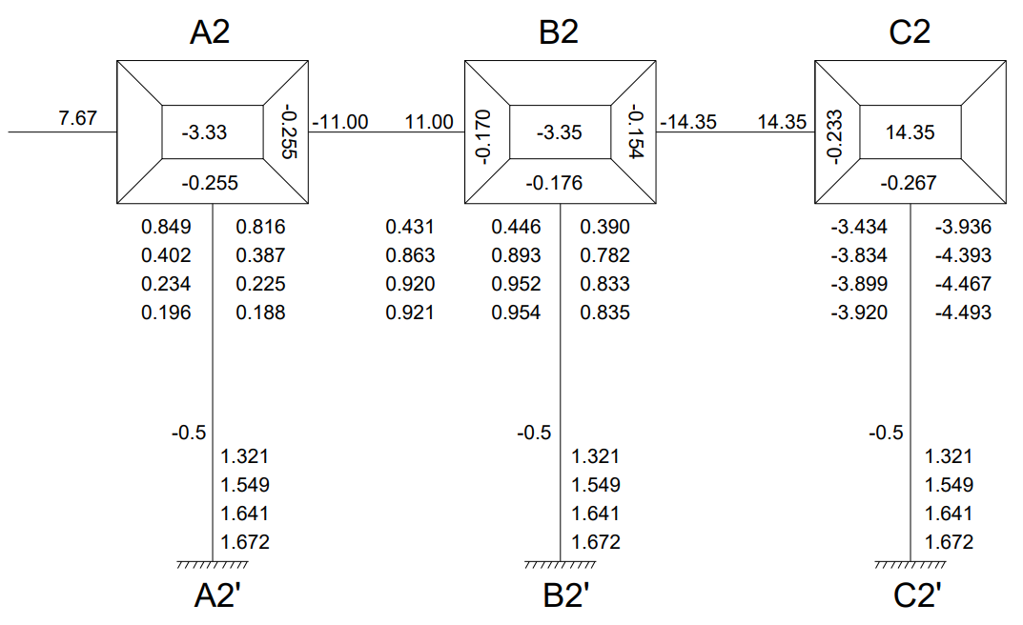
Cycle 1
Joint Rotation $\left(C.V. = R.F × \left[∑FEM+NCV+FCV\right]\right)$
M_{A2B2} = -0.245 × [-3.33 + 0 + 0] = 0.816
M_{A2A2՛} = -0.255 × [-3.33 + 0 + 0] = 0.849
M_{B2A2} = -0.170 × [-3.35 + 0.816 + 0] = 0.431
M_{B2C2} = -0.154 × [-3.35 + 0.816 + 0] = 0.390
M_{B2B2՛} = -0.176 × [-3.35 + 0.816 + 0] = 0.446
M_{C2B2} = -0.233 × [14.35 + 0.390 + 0] = -3.434
M_{C2C2՛} = -0.267 × [14.35 + 0.390 + 0] = -3.936
Displacement Contribution
For All Columns $\left(R.V. = D.F × \left[∑Rotations Contribution at Columns\right]\right)$
M_{A2A2՛} + M_{B2B2՛} + M_{C2C2՛} = -0.5 $×$ (0.849 + 0.446 + (-3.936)) = 1.321

Cycle 2
Joint Rotation $\left(C.V. = R.F × \left[∑FEM+NCV+FCV\right]\right)$
M_{A2B2} = -0.245 × [-3.33 + 1.321 + 0.431] = 0.387
M_{A2A2՛} = -0.255 × [-3.33 + 1.321 + 0.431] = 0.402
M_{B2A2} = -0.170 × [-3.35 + 1.321 + 0.387 + (-3.434)] = 0.863
M_{B2C2} = -0.154 × [-3.35 + 1.321 + 0.387 + (-3.434)] = 0.782
M_{B2B2՛} = -0.176 × [-3.35 + 1.321 + 0.387 + (-3.434)] = 0.893
M_{C2B2} = -0.233 × [14.35 + 1.321 + 0.782] = -3.834
M_{C2C2՛} = -0.267 × [14.35 + 1.321 + 0.782] = -4.393
Displacement Contribution
For All Columns $\left(R.V. = D.F × \left[∑Rotations Contribution at Columns\right]\right)$
M_{A2A2՛} + M_{B2B2՛} + M_{C2C2՛} = -0.5 $×$ (0.402 + 0.893 + (-4.393)) = 1.549

Cycle 3
Joint Rotation $\left(C.V. = R.F × \left[∑FEM+NCV+FCV\right]\right)$
M_{A2B2} = -0.245 × [-3.33 + 1.549 + 0.863] = 0.225
M_{A2A2՛} = -0.255 × [-3.33 + 1.549 + 0.863] = 0.234
M_{B2A2} = -0.170 × [-3.35 + 1.549 + 0.225 + (-3.834)] = 0.920
M_{B2C2} = -0.154 × [-3.35 + 1.549 + 0.225 + (-3.834)] = 0.833
M_{B2B2՛} = -0.176 × [-3.35 + 1.549 + 0.225 + (-3.834)] = 0.952
M_{C2B2} = -0.233 × [14.35 + 1.549 + 0.833] = -3.899
M_{C2C2՛} = -0.267 × [14.35 + 1.549 + 0.833] = -4.467
Displacement Contribution
For All Columns $\left(R.V. = D.F × \left[∑Rotations Contribution at Columns\right]\right)$
M_{A2A2՛} + M_{B2B2՛} + M_{C2C2՛} = -0.5 $×$ (0.234 + 0.952 + (-4.467)) = 1.641

Cycle 4
Joint Rotation $\left(C.V. = R.F × \left[∑FEM+NCV+FCV\right]\right)$
M_{A2B2} = -0.245 × [-3.33 + 1.641 + 0.920] = 0.188
M_{A2A2՛} = -0.255 × [-3.33 + 1.641 + 0.920] = 0.196
M_{B2A2} = -0.170 × [-3.35 + 1.641 + 0.188 + (-3.899)] = 0.921
M_{B2C2} = -0.154 × [-3.35 + 1.641 + 0.188 + (-3.899)] = 0.835
M_{B2B2՛} = -0.176 × [-3.35 + 1.641 + 0.188 + (-3.899)] = 0.954
M_{C2B2} = -0.233 × [14.35 + 1.641 + 0.835] = -3.920
M_{C2C2՛} = -0.267 × [14.35 + 1.641 + 0.835] = -4.493
Displacement Contribution
For All Columns $\left(R.V. = D.F × \left[∑Rotations Contribution at Columns\right]\right)$
M_{A2A2՛} + M_{B2B2՛} + M_{C2C2՛} = -0.5 $×$ (0.196 + 0.954 + (-4.493)) = 1.672

Step 4: Final End Moments
M_{ij} = FEM + 2×M_{ij} (Near end Rotation) + M_{ji} (Far end Rotation) +M՛՛ (Displacement)
Beams (No Sway M՛՛= 0) “for Joint A2, the Overhang Moment is a fixed constant of +7.67 KN-m”
M_{A2B2} = -11.00 + 2(0.188) + 0.921 = -9.70
M_{B2A2} = 11.00 + 2(0.921) + 0.188 = 13.03
M_{B2C2} = -14.35+ 2(0.835) + (-3.920) = -16.60
M_{C2B2} = 14.35 + 2(-3.920) + 0.835 = 7.35
Column (With Sway M՛՛= 1.672)
M_{A2A2՛} = 0 + 2(0.196) + 0 + 1.672 = 2.06
M_{A2՛A2} = 0 + 2(0) + 0.196 + 1.672 = 1.87
M_{B2B2՛} = 0 + 2(0.954) + 0 + 1.672 = 3.58
M_{B2՛B2} = 0 + 2(0) + 0.954 + 1.672 = 2.63
M_{C2C2՛} = 0 + 2(-4.493) + 0 + 1.672 = -7.31
M_{C2՛C2} = 0 + 2(0) + (-4.493) + 1.672 = -2.82
Equilibrium Check
“To check Joint A2, we must include that +7.67 overhanging moment along with the beam and column.”
Joint A2 = M_{overhanging} + M_{A2B2} + M_{A2A2՛} = 7.67 + (-9.70) + 2.06 = 0.03 ≈ 0
Joint B2 = M_{B2A2} + M_{B2C2՛ +} M_{B2B2՛} = 13.03 + (-16.60) + 3.58 = 0.01 ≈ 0
Joint C2 = M_{C2B2} + M_{C2C2՛} = 7.35 – 7.31 = 0.04 ≈ 0
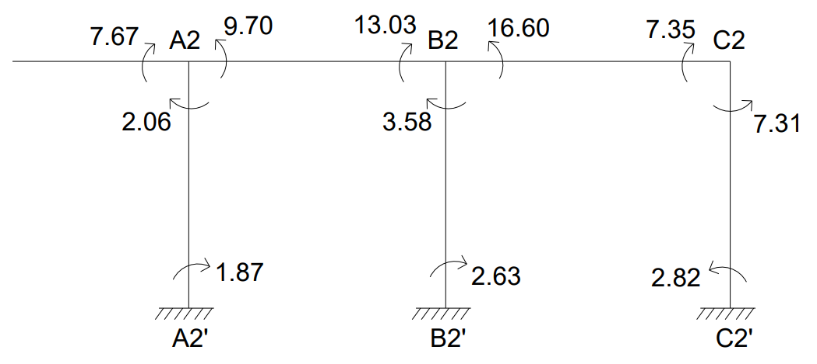
CALCULATION BENDING MOMENT
“Since the overhang is a cantilever, it doesn't have a simply supported "sagging" mid-span moment. Its moment is purely negative (hogging), starting at 0 at the free end and curving to 7.67 KN-m at support A2.”
BM_{A2B2} = $\frac{{WL}^{2}}{8}$ = $\frac{{16.84 ×2.8}^{2}}{8}$ = 16.50KN-m
BM_{B2C2} = $\frac{{WL}^{2}}{8}$ = $\frac{{17.92 ×3.1}^{2}}{8}$ = 21.53KN-m
BENDING MOMENT DIAGRAM
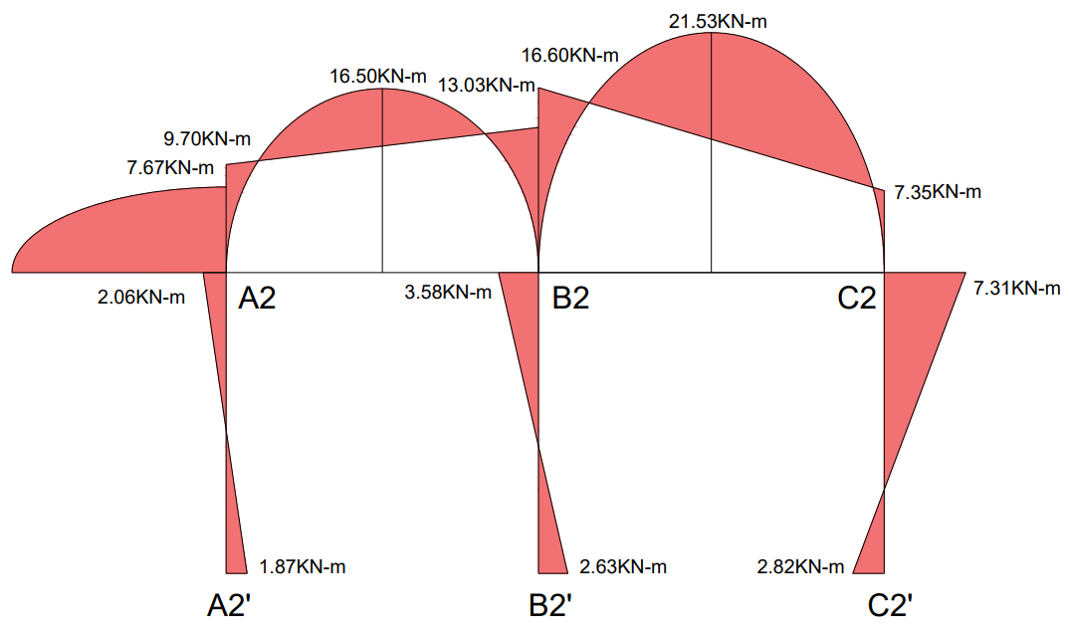
CALCULATION OF REACTIONS

From Overhang (Direct load transfer):
R_{overhang} = w × L = 4.16 × 1.92 = 7.99KN
For Span A2B2
Simply Supported Reactions:
R_{total} @ A2B2= $\frac{WL}{2}$ = $\frac{16.84 ×2.8}{2}$ = 23.58KN
Reaction Due to End Moments: (Net clockwise moment means left support gets less load)
R_{moment} @ A2B2= $\frac{M_{A2B2}- M_{B2A2}}{L}$ = $\frac{-9.70 + 13.03}{2.8}$ = -1.19KN
Reaction Due to End Moments: (Net clockwise moment means right support gets more load)
R_{moment} @ A2B2= $\frac{M_{A2B2}- M_{B2A2}}{L}$ = $\frac{+9.70 + 13.03}{2.8}$ = +1.19KN
For Span B2C2
Simply Supported Reactions:
R_{total} @ B2C2= $\frac{WL}{2}$ = $\frac{17.92 ×3.1}{2}$ = 27.78KN
Reaction Due to End Moments: (Net clockwise moment means right support gets less load)
R_{moment} @ B2C2= $\frac{M_{B2C2}- M_{C2B2}}{L}$ = $\frac{-16.60 + 7.35}{3.1}$ = -2.98KN
Reaction Due to End Moments: (Net clockwise moment means left support gets more load)
R_{moment} @ B2C2= $\frac{M_{B2C2}- M_{C2B2}}{L}$ = $\frac{16.60 + 7.35}{3.1}$ = +2.98KN
Final Reactions:
R_{A2} = R_{overhang} + R_{total} @ A2B2+ R_{moments} @ A2B2_{(Left Support)}
R_{A2} =7.99 + 23.58 + (-1.19) = 30.38KN
R _{B2} = (R_{total} @ A2B2+ R_{moments} @ A2B2_{(Right Support)}) + (R_{total} @ B2C2+ R_{moments} @ B2C2_{(Left Support)}) =
R _{B2} = (23.58 + 1.19) + (27.78 + 2.98) = 55.53
R _{C2} = R_{total} @ B2C2+ R_{moments} @ B2C2_{(Right Support)} =
R _{C2} = 27.78 + (-2.98) = 24.80 KN
